**CENWP-OD-B11 July 2023**

**MEMORANDUM FOR THE RECORD**

**SUBJECT: 23BON050 MFR WS LPS AWS RB1 and RB2 Pacific Lamprey Mortalities**

On the morning of 11 July, Project Biologists discovered one adult Pacific Lamprey mortality in Rest Box 1 of the Washington Shore Auxiliary Water Supply LPS. (WA Shore AWS LPS RB1) and one in the WA Shore AWS LPS Rest Box 2. The fish were scanned for PIT tags, inspected, and returned to the river.

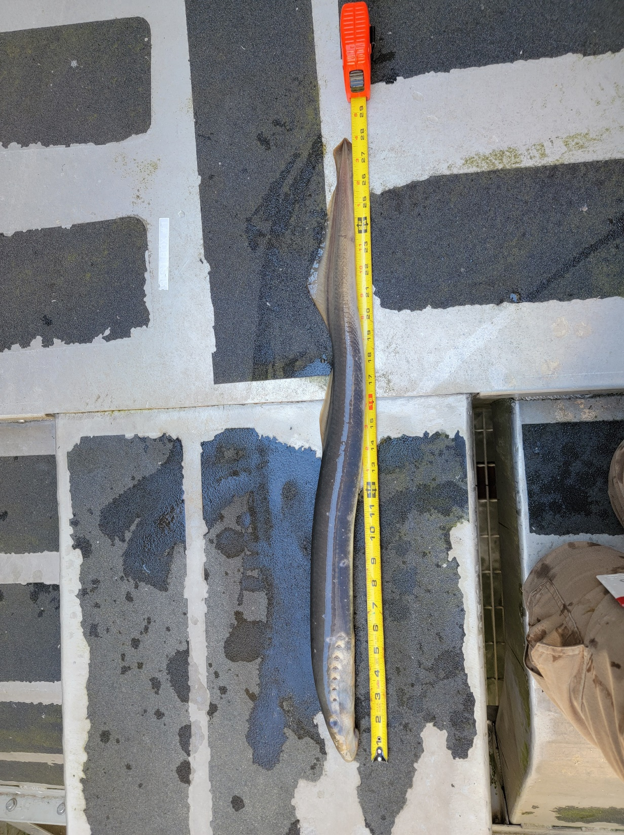

1. Species – Pacific Lamprey (*Entosphenus tridentatus)*
2. Origin – Unknown
3. Length –

#1 - 71.1 cm

#2 – 64.5 cm

1. Marks and tags – None
2. Marks and Injuries found on carcass – None
3. Cause and Time of Death – Unknown
4. 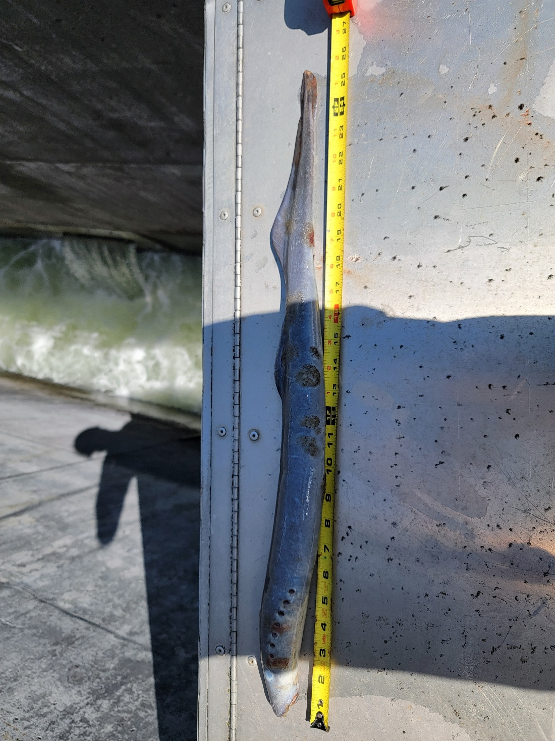Future and Preventative Measures – None

#1 – WA Shore AWS LPS RB1

#2 – WA Shore AWS LPS RB2

Sincerely,

Bonneville Project Fisheries